Data Structures

Lecture No. 39

Reading Material
Data Structures and Algorithm Analysis in C++ Chapter. 10
10.4.2

Summary
- Searching an Array: Binary Search
- Binary Search - Example 1
- Binary Search - Example 2
- Binary Search - Example 3
- Binary Search – C++ Code
- Binary Search – Binary Tree
- Binary Search - Efficiency
- Implementation 3 (of Table ADT): Linked List
- Implementation 4 (of Table ADT): Skip List
- Skip List - Representation
- Skip List - Higher Level Chains
- Skip List - Formally

Searching an Array: Binary Search
In the previous lecture, we had started discussion on Binary Search Tree algorithm. The discussion revealed that if already sorted data is available, then it is better to apply an algorithm of binary search for finding some item inside instead of searching from start to the end in sequence. The application of this algorithm will help get the results very quickly. We also talked about the example of directory of employees of a company where the names of the employee were sorted. For efficient searching, we constructed the binary search tree for the directory and looked for information about an employee named ‘Ahmed Faraz’.
We also covered:
- Binary search is like looking up a phone number or a word in the dictionary
- Start in middle of book
- If the name you're looking for, comes before names on the page, search in the first half
- Otherwise, look into the second half

The telephone directory is the quotable example to understand the way the binary search method works.

In this lecture, we will focus on data structures for performing search operation. Consider the data is present in an array as we discussed in the previous lecture. For the first implementation, we supposed that the data is not sorted in the array. For second implementation, we considered that the data inside the array is put in sorted array. The advantage of the effort of putting the data in the array in sorted order pays off when the searches on data items are performed.
Now, let’s first see the algorithm (in pseudo code) for this operation below. It is important to mention that this algorithm is independent of data type i.e. the data can be of any type numeric or string.

if ( value == middle element )
value is found
else if ( value < middle element )
search left half of list with the same method
else
search right half of list with the same method

The item we are searching for in this algorithm is called value. The first comparison of this value is made with the middle element of the array. If both are equal, it means that we have found our desired search item, which is present in the middle of the array. If this is not the case, then the value and the middle element are not the same. The else-if part of the algorithm is computed, which checks if the value is less than the middle element. If so, the left half part of the array is searched further in the same fashion (of logically splitting that half part of array into two further halves and applying this algorithm again). This search operation can also be implemented using the recursive algorithm but that will be discussed later. At the moment, we are discussing only the non-recursive algorithm. The last part of the algorithm deals with the case when the value is greater than the middle element. This processes the right half of the array with the same method.

Let’s see this algorithm in action by taking an example of an array of elements:

Binary Search – Example 1
Case 1: val == a[mid]
val = 10
low = 0, high = 8

mid = (0 + 8) / 2 = 4

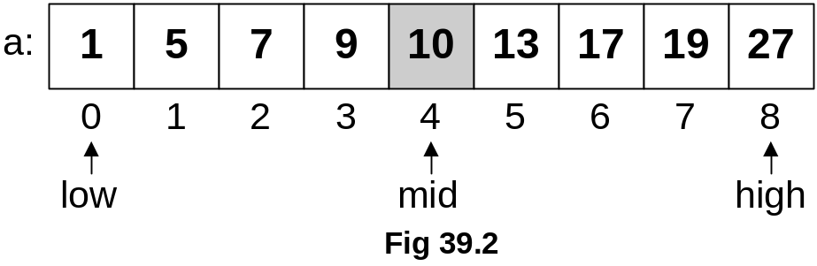

You can see an array a in the Fig 39.2 with indexes 0 to 8 and values 1, 5, 7, 9, 10, 13, 17, 19 and 27. These values are our data items. Notice that these are sorted in ascending (increasing) order.
You can see in the first line of case 1 that val = 10, which indicates that we are searching for value 10. From second line, the range of data to search is from 0 to 8. In this data range, the middle position is calculated by using a simple formula (low + high)/2. In this case, it is mid =(0+8)/2=4. This is the middle position of the data array. See the array in the above figure Fig 39.2, which shows that the item at array position 4 is 10, exactly the value we are searching for. So, in this case, we have found the value right away in the middle position of the array. The search operation can stop here and an appropriate value can be returned back.

Let’s see the case 2 now:

Binary Search – Example 2
Case 2: val > a[mid]
val = 19
low = 0, high = 8

mid = (0 + 8) / 2 = 4
new low = mid + 1 = 5

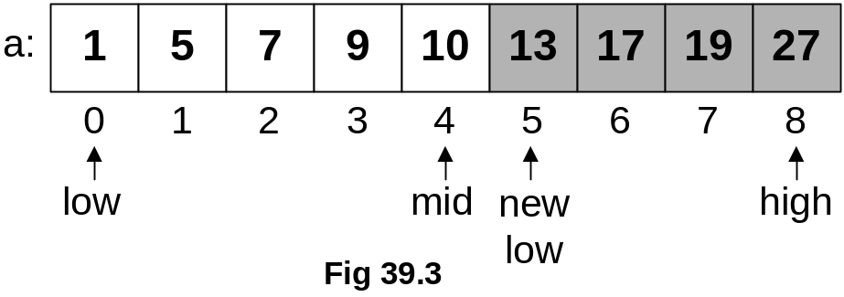
The second case is about the scenario when value (val) is greater than the middle value (a[mid]). The range of data items (low and high) is the same as that in case 1. Therefore, the middle position (mid) is also the same. But the value (val) 19 is greater than the value at the middle (mid) 10 of the array. As this array is sorted, therefore, the left half of the array must not contain value 19. At this point of time, our information about val 19 is that it is greater than the middle. So it might be present in the right half of the array. The right half part starts from position 5 to position 8. It is shown in Fig 39.3 that the new low is at position 5. With these new low and high positions, the algorithm is applied to this right half again.

Now, we are left with one more case.

Binary Search – Example 3
Case 3: val < a[mid]
val = 7
low = 0, high = 8

mid = (0 + 8) / 2 = 4
new high = mid - 1 =5

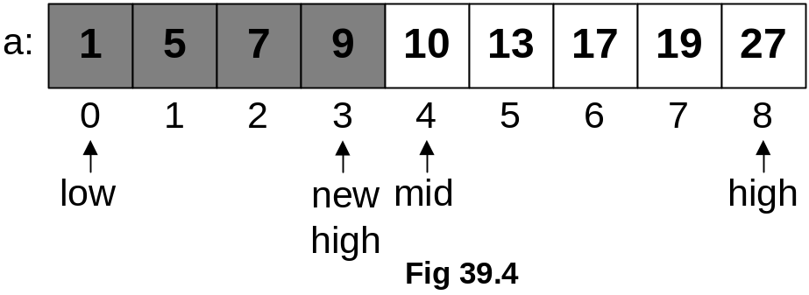
The value to be searched (val) in this case is 7. The data range is the same starting from low=0 to high=8. Middle is computed in the same manner and the value at the middle position (mid) is compared with the val. The val is less than the value at mid position. As the data is sorted, therefore, a value lesser than the one at mid position should be present in the lower half (left half) of the array (if it is there). The left half of the array will start from the same starting position low=0 but the high position is going to be changed to mid-1 i.e. 3. Now, let’s execute this algorithm again on this left half.
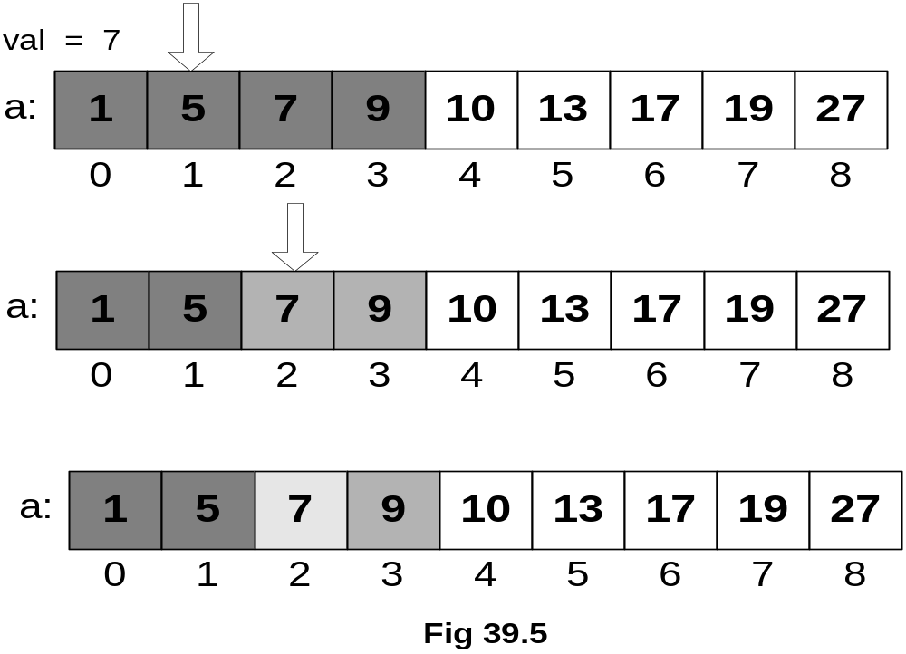

Firstly, we will compute the middle of 0 and 3 that results in 1 in this integer division. This is shown in the top array in Fig 39.5. Now, the val 7 is compared with the value at the middle position (mid) i.e.5. As 7 is greater than 5, we will process the right half of this data range (which is positioned from low=0 to high=3). The right half of this data range starts from position 2 and ends at position 3. The new data range is low=2 and high=3. The middle position (mid) is computed as (2+3)/2=2. The value at the mid position is 7. We compare the value at mid position (7) to the val we are looking for. These are found to be equal and finally we have the desired value.
Our desired number is found within positions- 0 to 8 at position 2. Without applying this binary search algorithm, we might have performed lot more comparisons. You might feel that finding this number 7 sequentially is easier as it is found at position 2 only. But what will happen in case we are searching for number 27. In that case, we have to compare with each element present in the array to find out the desired number. On the other hand, if this number 27 is searched with the help of the binary search algorithm, it is found in third comparison.
Actually, we have already seen binary search while studying the binary search tree. While comparing the number with the root element of the tree, we had come to know that if the number was found smaller than the number in the root, we had to switch to left-subtree of the root (ensuring that it cannot be found in the right subtree).

Now, let’s see the C++ code for this algorithm:

Binary Search – C++ Code
int isPresent(int *arr, int val, int N)
{
int low = 0;
int high = N - 1;
int mid;
while ( low <= high )
{
mid = ( low + high )/2;
if (arr[mid] == val)
return 1; // found!
else if (arr[mid] < val)
low = mid + 1;
else
high = mid - 1;
}
return 0; // not found

The name of the routine is isPresent, which expects an int pointer (an array in actual); an int value val is required to be searched. Another int value is N that indicates the maximum index value of the array. Inside the body of the function, int variables low, high and mid are declared. low is initialized to 0 and high is initialized to N-1. while loop is based on the condition that executes the loop until low <= high. Inside the loop, very first thing is the calculation of the middle position (mid). Then comes the first check inside the loop, it compares the val (the value being searched) with the number at middle position (arr[mid]). If they are equal, the function returns 1. If this condition returns false, it means that the numbers are unequal. Then comes the turn of another condition. This condition (arr[mid] < val) is checking if the value at the middle is less than the value being searched. If this is so, the right half of the tree is selected by changing the position of the variable low to mid+1 and processed through the loop again. If both of these conditions return false, the left half of the array is selected by changing the variable high to mid-1. This left half is processed through the loop again. If the loop terminates and the required value is not found, then 0 is returned as shown in the last statement of this function.
You change this function to return the position of the value if it is found in the array otherwise return –1 to inform about the failure. It is important to note that this function requires the data to be sorted to work properly. Otherwise, it will fail.

This algorithm is depicted figurative in Fig 39.6.

Binary Search – Binary Tree
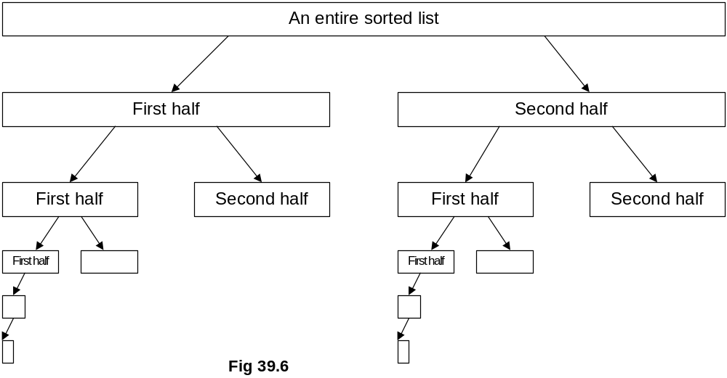

- The search divides a list into two small sub-lists till a sub-list is no more divisible.

You might have realized about the good performance of binary trees by just looking at these if you remember the fully balanced trees of N items discussed earlier.

Binary Search - Efficiency
To see the efficiency of this binary search algorithm, consider when we divide the array of N items into two halves first time.

After 1 bisection N/2 items
After 2 bisections N/4 = N/22 items
. . .
After i bisections N/2i =1 item
____________________________________

i = log2 N

First half contains N/2 items while the second half also contains around N/2 items. After one of the halves is divided further, each half contains around N/4 elements. At this point, only one of N/4 items half is processed to search further. If we carry out three bisections, each half will contain N/8 items. Similarly for i bisections, we are left with N/2^{i}, which is at one point of time is only one element of the array. So we have the equation here:
N/2i =1
Computing the value of i from this gives us:
i = log2 N
Which shows that after maximum log2 N bisections, either you will be successful in finding your item or fail to do so.

This was our second implementation of table or dictionary abstract data type using sorted sequential array. As discussed at start of it that if we implement table or dictionary abstract data type using an array, we have to keep the array elements in sorted order. An easier way to sort them can be that whenever we want to insert an element in the array, firstly we find its position (in sorted order) in the array and then shift the right side (of that position) elements one position towards right to insert it. In worst case, we might have to shift all the elements one position towards right just to keep the data sorted so this will be proportional to N. Similarly the remove operation is also proportional to N. But after keeping the data sorted, the search operation is returned within maximum log2 N bisections.

Implementation 3 (of Table ADT): Linked List
We might also use linked list to implement the table abstract data type. We can keep the data unsorted and keep on inserting the new coming elements to front in the list. It is also possible to keep the data in sorted order. For that, to insert a new element in the list, as we did for array, we will first find its position (in sorted order) in the list and then insert it there. The search operation cannot work in the same fashion here because binary search works only for arrays. Because the linked list may not be contiguous in memory, normally its nodes are scattered through, therefore, binary search cannot work with them.

- TableNodes are again stored consecutively (unsorted or sorted)
- insert: add to front; (1or n for a sorted list)
- find: search through potentially all the keys, one at a time; (n for unsorted or for a sorted list

- remove: find, remove using pointer alterations; (n)

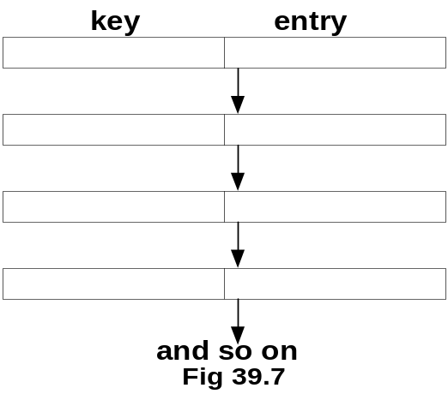

Well, linked list is one choice to implement table abstract data type. For unsorted elements, the insertion at front operation will take constant time.
(as each element is inserted in one go). But if the data inside the list is kept in sorted order then to insert a new element in the list, the entire linked list is traversed through to find the appropriate position for the element.

For find operation, all the keys are scanned through whether they are sorted or unsorted. That means the time of find is proportional to N.

For remove operation, we have to perform find first. After that the element is removed and the links are readjusted accordingly.

We know that when we used sorted array, the find operation was optimized. Let’s compare the usage of array and linked list for table abstract data type. The fixed size of the array becomes a constraint that it cannot contain elements more than that. Linked list has no such constraint but the find operation using linked list becomes slower. Is it possible to speed up this operation of find while using linked list? For this, a professor of University of Maryland introduced a new data structure called skip list. Let’s discuss little bit about skip list.

Implementation 4 (of Table ADT): Skip List
- Overcome basic limitations of previous lists
  - Search and update require linear time
- Fast Searching of Sorted Chain
- Provide alternative to BST (binary search trees) and related tree structures. Balancing can be expensive.
- Relatively recent data structure: Bill Pugh proposed it in 1990.

Important characteristics of skip list are stated above. Now, we see skip list in bit more detail.

Skip List - Representation
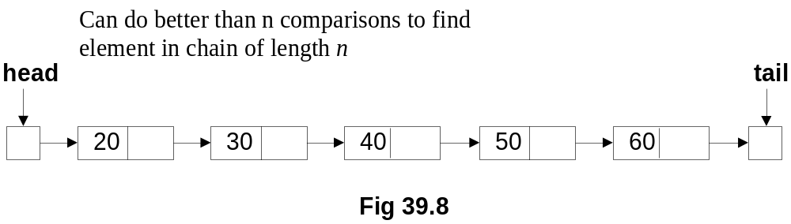

As shown in the figure. The head and tail are special nodes at start and end of the list respectively. If we have to find number 60 in the list then we have no other choice but starting from head traverse the subsequent nodes using the next pointer until the required node is found or the tail is reached. To find 70 in the list, we will scan through the whole list and then get to know that it is not present in it. The professor Pugh suggested something here:

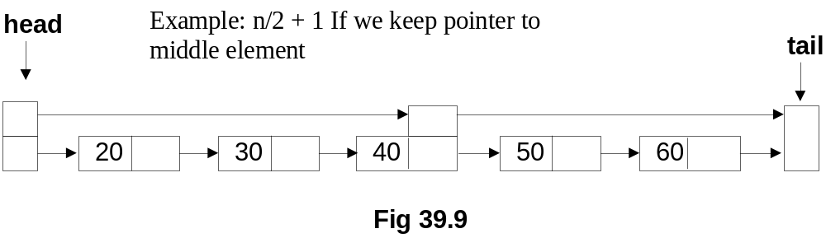
Firstly, we use two pointers head and tail. Secondly, the node in the middle has two next pointers; one is the old linked list pointer leading to next node 50 and the second is leading to the tail node. Additionally the head node also has two pointers, one is the old liked list pointer pointing to the next node 20 and second one is pointing to the middle element’s next pointer, which is (as told above) further pointing to the tail node.
Now, if we want to find element 60 in the above list. Is it possible to search the list in relatively quick manner than the normal linked list shown in Fig 39.8? Yes, it is with the help of the additional pointers we have placed in the list. We will come to the middle of the list first and see that the middle element (40) is smaller than 60, therefore the right half part of the list is selected to process further (as the linked list is sorted). Isn’t it the same we did in binary search? It definitely is.

What if we can add additional pointers (links) and boost the performance. See the figure below.

Skip List - Higher Level Chains
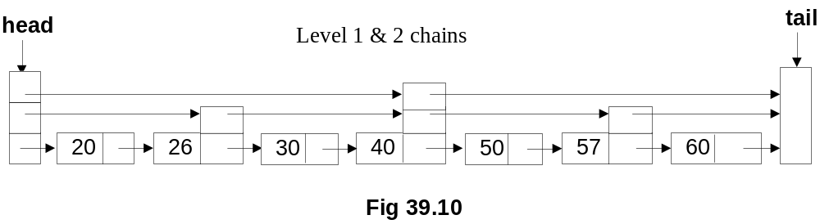

- For general n, level 0 chain includes all elements
- level 1 every other element, level 2 chain every fourth, etc.
- level i, every 2i th element

Level 0 chain is our old linked list chain as shown in Fig 39. Level 1 is new chain added to contain the link of every other node (or alternate node). Level 2 chain contains links to every 4th node. We keep on adding levels of chains so that we generalize that for level i chain includes 2ith elements. After adding these pointers, the skip list is no more our old linked list; it has become sort of binary tree. Still, there are still few important things to consider.

- Skip list contains a hierarchy of chains
- In general level i contains a subset of elements in level i-1

Skip list becomes a hierarchy of chains and every level contains a subset of element of previous level. Using this kind of skip list data structure, we can find elements in log₂n time. But the problem with this is that the frequency of pointers is so high as compared to the size of the data items that it becomes difficult to manage them. The insert and remove operations on this kind of skip list become very complex because single insertion or removal requires lot of pointers to readjust.
Professor Pugh suggested here that instead of doing leveling in powers of 2, it should be done randomly. Randomness in skip lists is a new topic for us. Let’s see a formal definition of skip list.

Skip List - Formally
- A skip list for a set S of distinct (key, element) items is a series of lists S0, S1 , … , Sh such that
  - Each list Si contains the special keys +∞ and −∞
  - List S0 contains the keys of S in non-decreasing order
  - Each list is a subsequence of the previous one, i.e.,
S0 ⊇ S1 ⊇ … ⊇ Sh
  - List Sh contains only the two special keys

You are advised to study skip list from your text books. The idea of randomness is new to us. We will study in the next lecture, how easy and useful becomes the skip list data structure after employing randomness.

